LOYOLA COLLEGE (AUTONOMOUS), CHENNAI – 600 034
M.A. DEGREE EXAMINATION - ENGLISH LITERATURE
SECOND SEMESTER – APRIL 2012

EL 2807 - MEDIA CRAFT

Date : 24-04-2012 Dept. No. Max. : 100 Marks

Time : 9:00 - 12:00

- Answer any TEN of the following in about 75 words each: 10 x 3 = 30

- What are the three phases of Book packaging
- Explain the two types of Reporting.
- State the arguments of Lippman and Dewey.
- News gathering- Explain.
- What is LEAD and five ‘W’s?
- Explain the types of headlines
- Is mass communication equal to group communication? Why?
- Why is it said that mass communication is controlled by ‘ elites’ ?
- What are the four waves of media?
- What is paid news?
- Are news papers, newspapers or viewspapers?
- Is mass media cost intensive or labour intensive? Explain.

- Answer any FIVE of the following in about 150 words each: 5 x 8 = 40
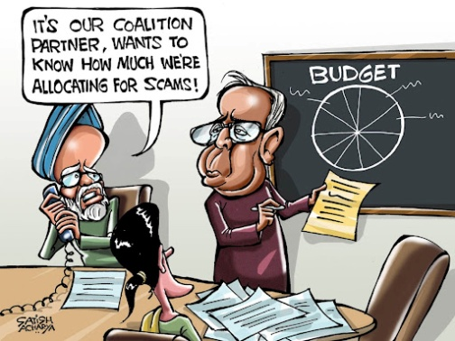
- Write an opinion article for the following cartoon

Visually challenged students to answer question 13.a

13.a. (only for visually challenged) Bring out the implications of the budget 2012.
- What are the tips for writing an obituary?
- Write a letter to the editor about the status of women in India today.
The neighborhood of around a hundred of buildings with more than 800 small rooms is one of the 14 official brothels of Bangladesh, but are in essence a prison for around 900 sex workers. The young sex workers of this brothel must serve at least 10-15 customers each day. It is common practice among prostitutes of Kandapara brothel in Tangail to take steroids like Oradexon — a steroid used by farmers to fatten their cattle. The drug can be found in any tea or cigarette stall around the brothel. It increases their appetite, making them gain weight rapidly and giving the appearance that these poorly nourished teens are in fact healthy and older - attracting clients who prefer girls with "curves".Oradexon, they say, keeps them going, even though there are known risks associated with its long-term use. Here is a photo essay by Andrew Biraj that takes a look at the dark secret behind Bangladesh's "teenage" brothels.
- Write a paragraph on how the scenes in mass media give an apparent seamless stitching.
- Do you agree that the press should be free of any control? Explain.
- Marginalisation of certain sections of the society is media made. Explain .

- Answer the following in about 300 words each: 2 x 15 = 30

- a. What are the tips for writing an obituary and write an obituary

(OR)
b. What do you mean by proof reading and the symbols that are used in proof reading?
Visually challenged students to answer question 19.b.a/b

19.b.a. (only for visually challenged) what are the tips for writing an obituary and write an obituary for a famous person.
(OR)
b.What is the relevance of Print Media and the how is it classified?
20 .a. Evolve a framework for Developmental communication.
(OR)
b. In the name of exposing politicians and other hi profile persons media compromises on ethics:
Discuss the above mentioned point with reference to recent happening in the news world.

******************

